- Title and Author
Assignment 2
110704008 羅瑋翔
xianglo9121.mg10@nycu.edu.tw
- Statement of The Problem
In this assignment, we are discussing about the efficiency of different sorting algorithms. (1) Insertion sort (2) Selection sort (3) Quick sort (4) Merge sort (5) Heap sort, respectively. And the difference algorithms will sort n elements, where the range of n is from 10000 to 100000. To calculate the CPU time that each sorting algorithm cost, I include the head file <ctime> and create the variable with the data type clock_t. Then print the result on a txt file and save it.
- Main Results.
- Description of the design of My Program
(In the main function)
First create the not ordered sequence randomly. And I let different algorithms sort the same sequence, this way, we can prevent different algorithms run different cases. Such as, some runs the better cases, some runs the worse cases.
Then the following part used to calculate the CPU time that the algorithm used while sorting.
Then the last part is the debug mode. I print the array after sorting to check if the algorithm is right or not.
(functions)
The whole code is in the part (3 –c). Here, I only introduce what are the function used for, and the functions are called while the CPU time calculating.
- iSort() : Pass the array, and the size of the array to this function. Then use Insertion sort to sort it.
- sSort() : Pass the array, and the size of the array to this function. Then, use selection sort to sort it.
- qSort() : Sent the array, the index of left, and the index of right to this function. Then use the method, recursion, to call this function until the stopping case.
- mSort() : Sent the array, the index of left, and the index of right to this function. (Divide part) Continuously call the function itself until facing with the stopping case.
- merge() : (Conquer part) This part deal with the sub ordered subarray. Enables the subarray to comparing value and sent the ordered values to the array which is needed to be sorted.
- hSort() : Sent the array and its size to this function, and call the heapify function.
- heapify() : Sent the array, its size, and the index of the root to this function. To change nodes, enabling the tree to become max heap.
- Array is the data structure I used in this program. This data structure is used to save the sequence which is randomly generated. I use array because it helps me easily save the sequence one-by-one in a row. And do the same thing only changing the index of the array. If not using it, I might create a lot of variables, and the code would be very long.
- The whole program is below.
#include<iostream>
#include<iomanip>
#include<ctime>
#include<cstring>
#include<cstdlib>
#include<fstream>
using namespace std;

int data1[100000], data2[100000], data3[100000], data4[100000], data5[100000];

void iSort(int data[], int n);

void sSort(int data[], int n);

void qSort(int data[], int left, int right);

void mSort(int data[], int l, int r);

void merge(int data[], int l, int m, int r);

void hSort(int data[], int n);

void heapify(int data[], int n, int i);

int main(){
ifstream inFile;
ofstream outFile;
//cout the result in result.txt file. It can help me easily and clearly compare the result of each algorithms
outFile.open("result1.txt");
const int n1 = 10000, n2 = 100000;
srand(time(NULL));
outFile << setw(10) << "n" << setw(20) << "Insertion Sort" << setw(20) << "Selction Sort" << setw(15)
<< "Quick Sort"<< setw(15) << "Merge Sort" << setw(15) << "Heap Sort" << endl;

//the following step calculate the CPU time that each sorting methods cost
for(int i = n1; i <= n2; i += 1000){
double iTime = 0, sTime = 0, qTime = 0, mTime = 0, hTime = 0;
int used[i + 10] = {0};
int j;
for(j = 0; j < i; j++){
//since the random number(the compiler offered) is range from 0 ~ 32767 so I do the methods below to deal with it.
int temp = ((rand() << 15) + rand()) % i + 1;
//the used array record the numbers which had been generated.
if(used[temp] == 0){
data1[j] = temp;
data2[j] = temp;
data3[j] = temp;
data4[j] = temp;
data5[j] = temp;
used[temp] = 1;
}
else{
j--;
}
}
//this part only calculate the time used in sorting
clock_t clicks1 = clock();
iSort(data1, i);
clicks1 = clock() - clicks1;
iTime += (double)clicks1 / CLOCKS_PER_SEC;

clock_t clicks2 = clock();
sSort(data2, i);
clicks2 = clock() - clicks2;
sTime += (double)clicks2 / CLOCKS_PER_SEC;

clock_t clicks3 = clock();
qSort(data3, 0, i - 1);
clicks3 = clock() - clicks3;
qTime += (double)clicks3 / CLOCKS_PER_SEC;

clock_t clicks4 = clock();
mSort(data4, 0, i - 1);
clicks4 = clock() - clicks4;
mTime += (double)clicks4 / CLOCKS_PER_SEC;

clock_t clicks5 = clock();
hSort(data5, i);
clicks5 = clock() - clicks5;
hTime += (double)clicks5 / CLOCKS_PER_SEC;
outFile << setw(10) << i << setw(20) << iTime << setw(20) << sTime << setw(15)
<< qTime << setw(15) << mTime << setw(15) << hTime << endl;
//debug mode.
for(int j = 0; j < i; j++){
cout << setw(10) << data1[j] << setw(10) << data2[j] << setw(10) << data3[j] << setw(10)
<< data4[j] << setw(10) << data5[j] << endl;
}
}
outFile.close();

system("PAUSE");
return 0;
}

void iSort(int data1[], int n){
for(int i = 1; i < n; i++){
int y = data1[i];
int j = i - 1;
while(y < data1[j] && j >= 0){
data1[j + 1] = data1[j];
j--;
}
data1[j + 1] = y;
}
}

void sSort(int data2[], int n){
for(int i = 0; i < n; i++){
for(int j = i + 1; j < n; j++){
if(data2[i] > data2[j])
{
int tmp = data2[i];
data2[i] = data2[j];
data2[j] = tmp;
}
}
}
}

void qSort(int data3[], int left, int right){
int i = left, j = right + 1, tmp;
if(left < right){
while(i < j){
while(data3[++i] < data3[left]);
while(data3[--j] > data3[left]);
if(i >= j)
break;
tmp = data3[i];
data3[i] = data3[j];
data3[j] = tmp;
}
tmp = data3[j];
data3[j] = data3[left];
data3[left] = tmp;
qSort(data3, left, j - 1);
qSort(data3, j + 1, right);
}
}

void merge(int data[], int l, int m, int r)
{
int i, j, k;
int n1 = m - l + 1;
int n2 = r - m;
int L[n1], R[n2];
for (i = 0; i < n1; i++)
L[i] = data[l + i];
for (j = 0; j < n2; j++)
R[j] = data[m + 1 + j];
i = 0;
j = 0;
k = l;
while (i < n1 && j < n2) {
if (L[i] <= R[j]) {
data[k] = L[i];
i++;
}
else {
data[k] = R[j];
j++;
}
k++;
}
while (i < n1) {
data[k] = L[i];
i++;
k++;
}
while (j < n2) {
data[k] = R[j];
j++;
k++;
}
}

void mSort(int data[], int l, int r)
{
if (l < r) {
int m = l + (r - l) / 2;
//the devide part
mSort(data, l, m);
mSort(data, m + 1, r);
//the conquer part
merge(data, l, m, r);
}
}

void hSort(int data5[], int n){
for(int i = n / 2 - 1; i >= 0; i--)
heapify(data5, n, i);
for(int i = n - 1; i > 0; i--){
int temp = data5[0];
data5[0] = data5[i];
data5[i] = temp;
heapify(data5, i, 0);
}
}

void heapify(int data5[], int n, int i){
//initialize largest as root
int largest = i;
int l = 2 * i + 1;
int r = 2 * i + 2;

if(l < n && data5[l] > data5[largest])
largest = l;
if(r < n && data5[r] > data5[largest])
largest = r;
if(largest != i){
int temp = data5[i];
data5[i] = data5[largest];
data5[largest] = temp;
heapify(data5, n, largest);
}
}
- Outputs of the compilation and the executions
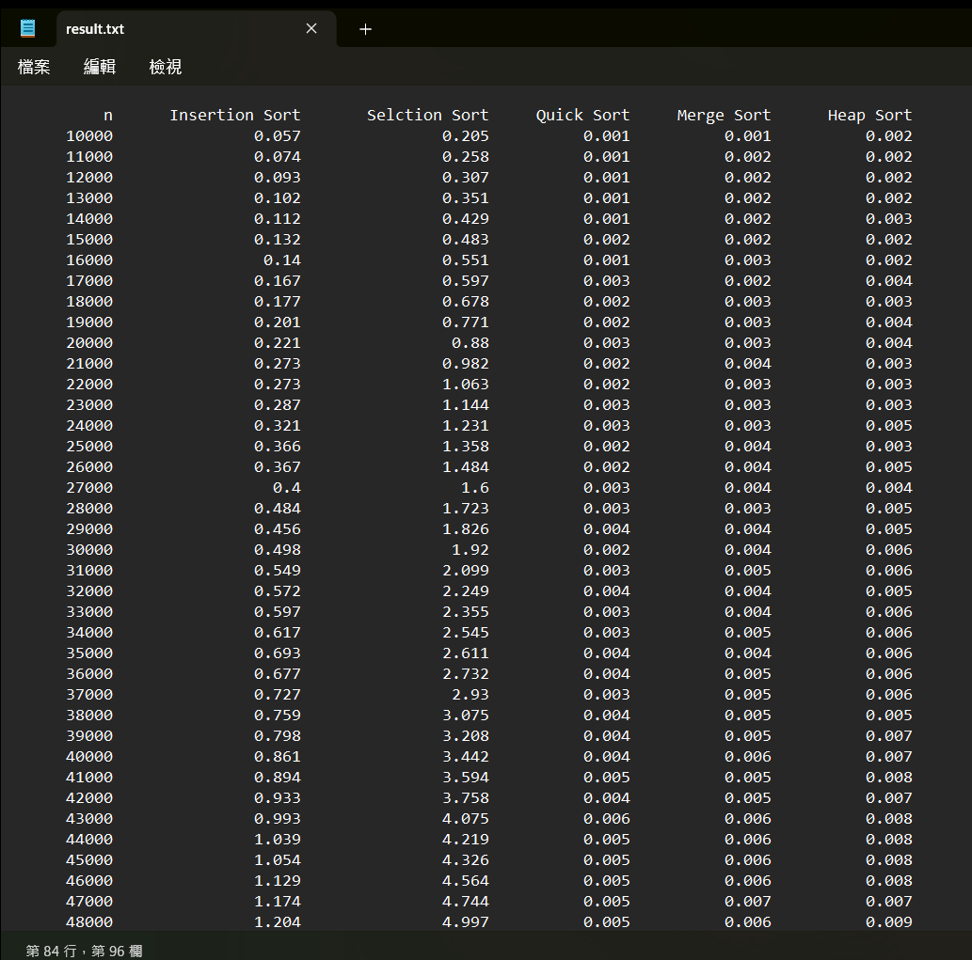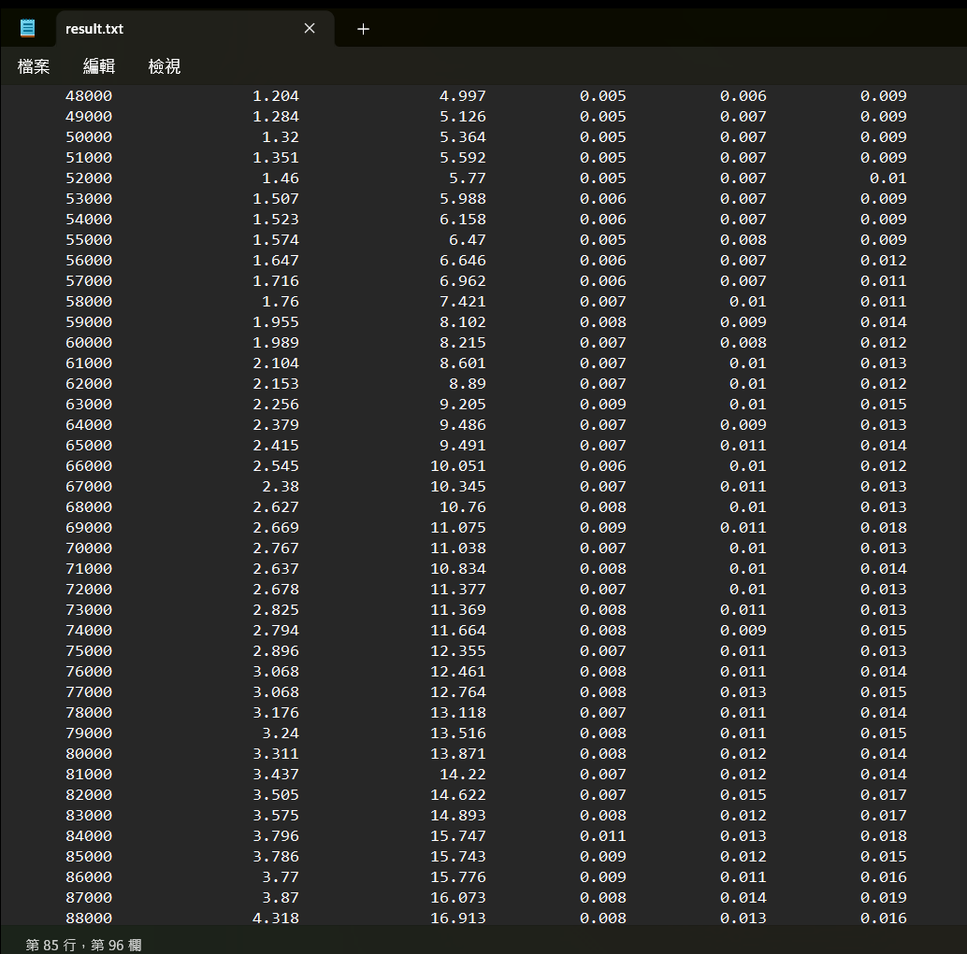
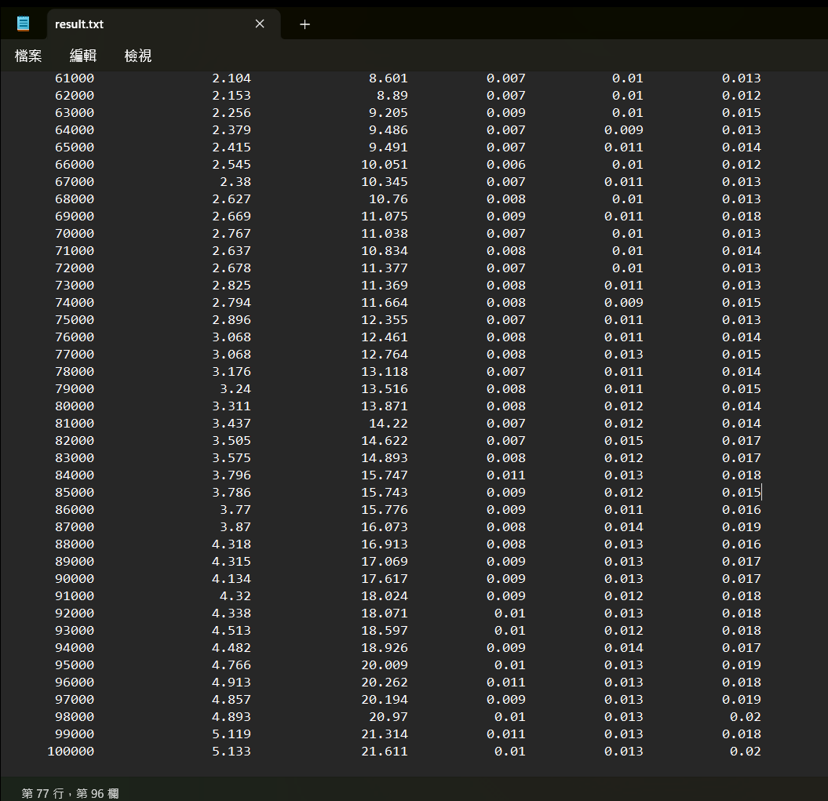
(4) Conclusions.
While doing this homework, I faced with two big problems, and finally I solved them. (1) At the first time, compiling my program, the randomly generating sequence is the code below.
Int temp = rand() % I + 1; Then the program will stop at n (the elements) = 32767. Why? Because of my compile environment, the range of random number is from 0 to 32767. Hence I rewrite the code as perform in 3-c part. (2) I faced another problem after I solved the first problem. My program will stop at n = 74000. At that time, the array(data1[100000], data2[100000], ……) are not global variables. The code is performed as below at that time.
for(int i = n1; i <= n2; i += 1000){
double iTime = 0, sTime = 0, qTime = 0, mTime = 0, hTime = 0;
int data1[i], data2[i], data3[i], data4[i], data5[i];
int used[i + 10] = {0};
int j;
. . . . . .
I discovered that the problem might happen because the space to save the array is not enough. So, I wrote the array as global variables.
But this question is not sure now. I would ask the question in the class on Tuesday. Faced with these problems are the most interesting part while doing this assignment, since I can learn more things that will not occur in the class.

